**Environment Setup**

**Create a Flask Project**

|  |  |
| --- | --- |
| Team ID | PNT2022TMID36311 |
| Project Name | Nutrition Assistant Application |

**Code :**

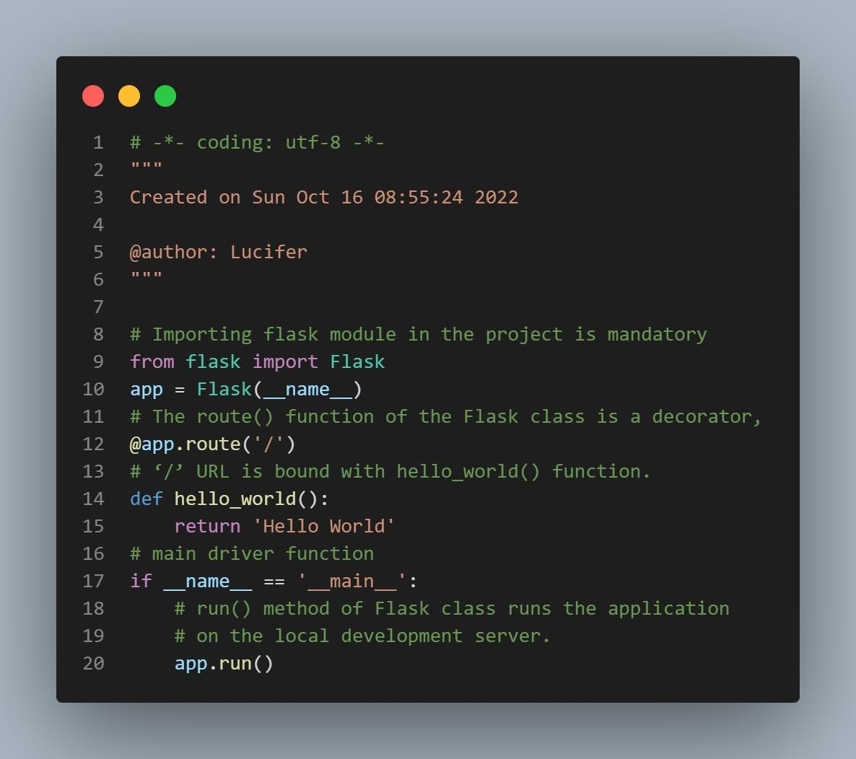

**Terminal :**

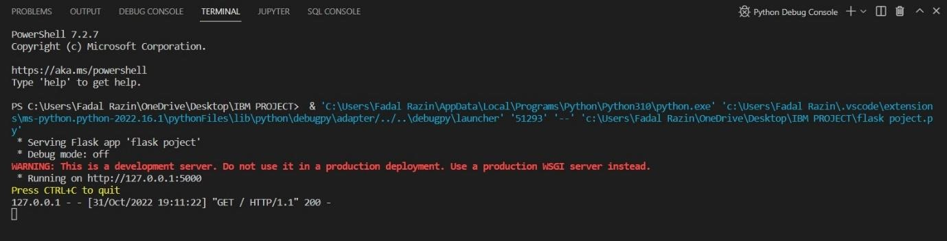

**Page :**

